Easter – Wielkanoc

Słówka do wprowadzenia:
Eggs – pisanki
Bunny – zajączek
Easter basket – koszyczek
Chick – kurczaczek

Piosenka:
https://elt.oup.com/student/goldsparks/level1/songs/easter?cc=pl&selLanguage=pl
How manyeggs in the Easter basket?
How manyeggs in the Easter basket?
How manyeggs in the Easter basket?
One, two, three, four, five.
Five eggs in the Easter basket.
Five eggs in the Easter basket.
Five eggs in the Easter basket.
One, two, three, four, five.
Whatcolourare the eggs in the Easter basket?
Lookat the eggs in the Easter basket.
Whatcolourare the eggs in the Easter basket?
Lookat the eggs in the Easter basket.
One ispink, one ispurple.
One isgreen, one isyellow.
One ispink and green and purple.
Look in the Easter basket.

Karty pracy do wydrukowania i wykonania przez dziecko.

Wytni obrazki znajdujące się na dole karty i powklejaj brakujące obrazki, tak aby zachować rytm (wzór).
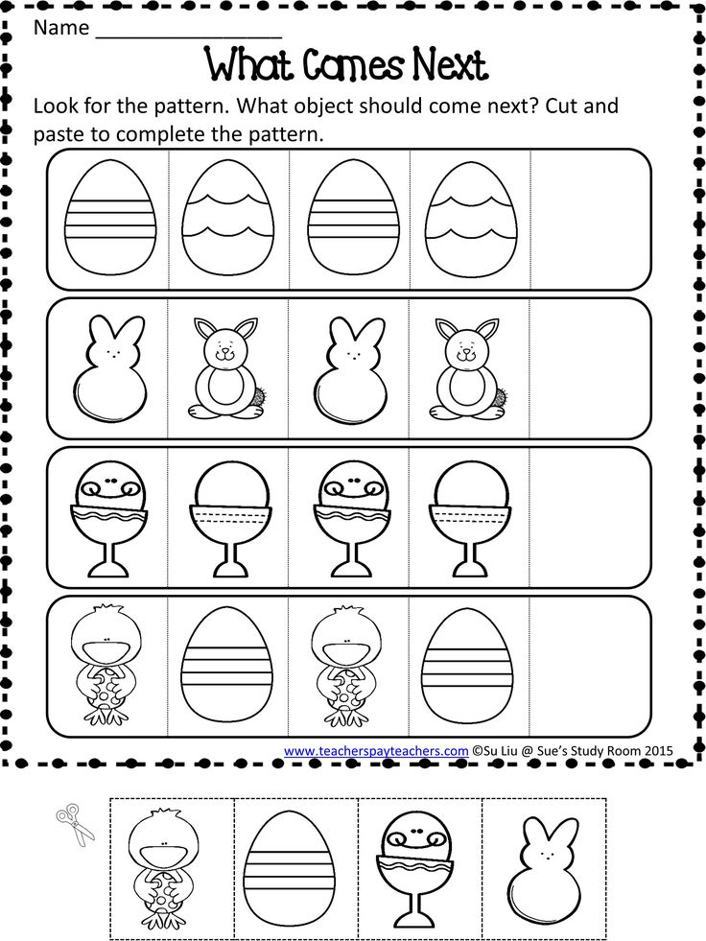

Pomóż zajączkowi odnaleźć jego koszyczek.

